The Royal College of Psychiatrists in Scotland  Autumn Conference  Friday 3rd October  Online Zoom Event | 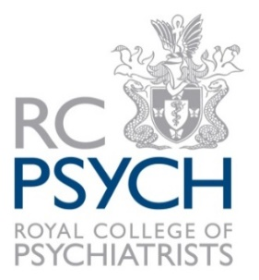

CALL FOR ABSTRACTS

Title of presentation:
Name and grade of presenter:

Contact Address

Tel:
Email:
Place of work:

DETAILS OF PROPOSAL
Abstracts should be no longer than 400 words.

Please complete and return the attached form to: angela.currie@rcpsych.ac.uk with the subject reference (your name – Abstract submission RCPsychiS Oct 2025)

CLOSING DATE
Friday 8th August 2025
Contact regarding submissions: Angela Currie, Coordinator, RCPsych in Scotland
Email: angela.currie@rcpsych.ac.uk or Tel: 0131 344 4967

