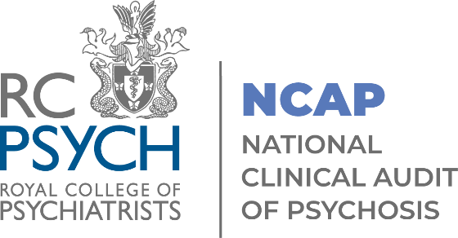

NCAP
Quality Improvement Collaborative

Template workbook for the enhanced programme
May 2024 -May 2025

If you have any questions relating to this workbook, please contact ncapqi@rcpsych.ac.uk

Trust/Health Board name:
EIP team name:
Your problem/area for improvement:
What do you KNOW is contributing to your problem?
What do you THINK Might be contributing to your problem?
What data/tools/conversations could help you find out what’s really going on?
Actions: Once you have started to pick apart your area for improvement it is helpful to think what information you need to collect (and who needs to collect it) to "diagnose” the problem, this may include reviewing existing data e.g. the current % of patients being offered family intervention and consider collecting new data such as staff surveys.
What |  | By whom |  | By when | Other
Aim statement:
- Make sure your aim is ‘SMART’.
- Make sure your aim has a numerical value and an end date.
- Sometimes you may need to take a slightly different perspective, so your aim is ‘owned’ by the team.
- Ensure your aim is operationally defined.
- Ensure everyone has a shared understanding of your aim.
- You may need to modify your aim if you reach you goal more quickly than you expected.

Example: “Our aim is to increase the uptake of family intervention by 10% by May 2024.”
What do you want to improve?
For whom? (population)
By how much? (target)
By when? (timeframe)
Your aim statement:
Your Team
Think about who needs to be part of your core QI team.
- What are you going to need and who can help you? e.g., admin support, staff cover?
- Who really understands the system that you are trying to improve so that you can work out what is causing the problem?
- Who will be affected by the changes you are trying to make? Are they likely to stop you?
- Who are the people who like to get involved with new ideas?
- For all the above: do they need to be involved on a day-to-day basis (actively) or kept up to speed (passively)?
Actively involved:

Passively involved:

Your outcome measures:
Outcome measure = progress towards the aim.
Baseline outcome measure (before you test out any changes): the current percentage of service users that take up or decline the offer of family intervention.
Ongoing outcome measure: the percentage of service users that take up the offer of family intervention (per week/month).

Example: Aim: to increase the uptake of family intervention by 10% by May 2024.
Outcome measure: The percentage of patients that take up the offer of family intervention per week/month.
Your change ideas:
Example: Trial a buddy system where experienced members of the team offer family interventionI with other members of the team who are less experienced/confident in offering the intervention.
Change idea i.e., what you want to achieve |  |  | Associated measure (if needed)
1.
2.
3.
4.
5.
6.

Your first PDSA cycle:
Who has responsibility for this PDSA?
What are you hoping to find out?
PLAN

Complete when you are developing your improvement plan for this cycle.

- What are you going to do?
- Who will be involved and how?
- When will it take place?
- How will it be done?
- What will you measure?
- What are your expectations?
DO
(Did)

Complete once you have tested your improvement idea.

- How did you implement the plan?
- Did you encounter any unexpected problems?
- Did you achieve any unexpected benefits?
STUDY
(Studied)

Complete once you have reviewed your results.

- What results did you achieve (add in your before and after data),
- Did they differ from your expectations? If so, how?
- What have your learnt from this cycle?
ACT
(Acted)

Complete once you have finished testing your change idea and are planning your next improvement cycle.

What action(s) will you now take to either:
- Refine and re-test your improvement idea?
- Implement and embed the change?
- Reject the idea and prepare to test a new one?

Your second PDSA cycle:
Who has responsibility for this PDSA?
What are you hoping to find out?
PLAN

Complete when you are developing your improvement plan for this cycle.

- What are you going to do?
- Who will be involved and how?
- When will it take place?
- How will it be done?
- What will you measure?
- What are your expectations?
DO
(Did)

Complete once you have tested your improvement idea.

- How did you implement the plan?
- Did you encounter any unexpected problems?
- Did you achieve any unexpected benefits?
STUDY
(Studied)

Complete once you have reviewed your results.

- What results did you achieve (add in your before and after data),
- Did they differ from your expectations? If so, how?
- What have your learnt from this cycle?
ACT
(Acted)

Complete once you have finished testing your change idea and are planning your next improvement cycle.

What action(s) will you now take to either:
- Refine and re-test your improvement idea?
- Implement and embed the change?
- Reject the idea and prepare to test a new one?

